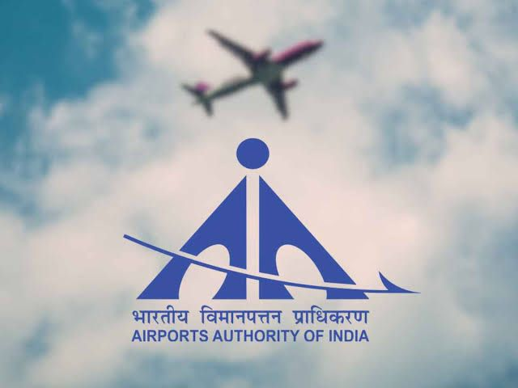

**Start pages**

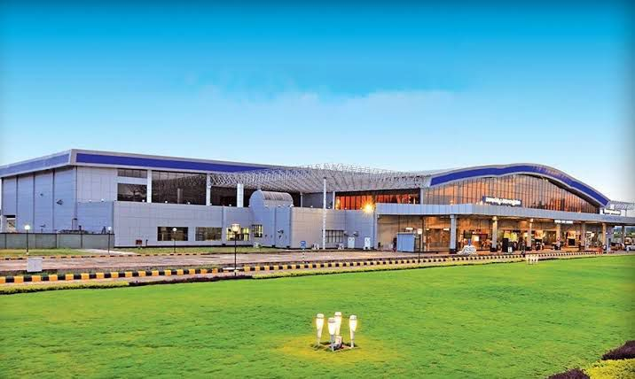

The Visakhapatnam International Airport was initially an Indian Navy Airbase called INS Dega. It started operating as a civil airport only in 1981.

* **Runway**

The original runway was 6,000 ft long, but a new 10,007 ft runway was inaugurated in 2007.

* **Terminal**

A new terminal building was inaugurated in 2009 and became operational later that year.

* **Instrument landing system**

The ILS was installed on Runway 28 and became operational for commercial aircraft in 2008.

* **Renaming**

The airport was officially renamed Alluri Sitarama Raju International Airport in September 2024.

**Certificate**

Certified that the Internship project in Finance and Accounts, Airports Authority of India presented by Mr. janakiram and teja sai krishna , M.B.A. (Business analytics), School of international business represents his original work which was carried out by her at Finance and Accounts Department of AAI visakhaptanam under my guidance and supervision during the period from

Name of Guide/Mentor:

Signature of Guide:

Date:

**Acknowledgement**

I am grateful to Andhra University for giving me an opportunity to showcase my interest and talent in the form of this internship project. I am also thankful to the entire management of School of international business for making all the facilities. Available on time.

The success of my internship largely depends on the encouragement and guidelines of Mr ….(Deputy General Manager Finance) and Mr ……(Manager Finance), my project guide who guided me despite their very hectic schedule. Without their Support and Guidance this project would not have been completed.

Also, would like to thank Mr ……for giving me timely information whenever needed.

Hence, I take this opportunity to express my gratitude to thank my Family Members, Faculty Members & Friend as they have been instrumental in the successful completion of this project.

**ABSTRACT**

**Table of content**

|  |  |  |
| --- | --- | --- |
| **Serial.no** | **Name of the topic** | **Page.no** |
| **1** |  |  |
| **2** |  |  |
| **3** |  |  |
| **4** |  |  |
| **5** |  |  |
|  |  |  |
|  |  |  |
|  |  |  |
|  |  |  |
|  |  |  |
|  |  |  |
|  |  |  |
|  |  |  |
|  |  |  |
|  |  |  |
|  |  |  |
|  |  |  |



भारतीय विमानपत्तन प्राधिकरण

AIRPORTS AUTHORITY OF INDIA

|  |
| --- |
| ध्येय |

विमान यातायात सेवाओं एवं हवाई अड्डा प्रबंधन में नेतृत्व करते हुए विश्वस्तरीय संगठन बनाना एवं 2016 तक एशिया प्रशांत क्षेत्र में भारत को एक प्रमुख केन्द्र बनाना।

**Vision**

To be a world-class organization providing leadership in air traffic services and airport management and making India a major hub in Asia Pacific Region by 2016.

|  |
| --- |
| उद्देश्य |

राष्ट्र के आर्थिक विकास और समृद्धि में योगदान करते हुए ग्राहक की सम्पूर्ण संतुष्टि के लिए अत्याधुनिक अवसंरचना उपलब्ध कराते हुए विमान यातायात सेवाओं और हवाई अड्डा प्रबंधन में सुरक्षा एवं गुणवत्ता के उच्चतम स्तर प्राप्त करना।

**Mission**

To achieve highest standards of safety and quality in air traffic services and airport management by providing state-of-the-art infrastructure for total customer satisfaction, contributing to economic growth and prosperity of the nation.

FINANCIAL DEPARTMENT Whenever you fly, you are in safe hands of AAI



PORFILE

OF

AIRPORTS AUTHORITY OF INDIA

BY FINANCIAL DEPARTMENT



**PROFILE OF AIRTPORTS AUTHOSRITY OF INDIA**

**INTRODUCTION**

Airports Authority of India (AAI) came to existence on 1st April 1995. AAI has been constituted as a Statutory Authority under the Airports Authority of India Act, 1994. It has been created by merging the erstwhile International Airports Authority of India and National Airports Authority with a view to accelerate the integrated development, expansion and modernization of the air traffic services, passenger terminals, operational areas and cargo facilities at the airports in the country.

The main functions of the Authority are as under:-

Control and management of the Indian air space (excluding special user air space) extending beyond the territorial limits of the country as accepted by ICAO.

Provision of Communication, Navigational and Surveillance Aids.

Expansion and strengthening of operational areas viz. Runways, Aprons, Taxiways, etc. and provision of ground based landing and movement control aids for aircrafts & vehicular traffic in operational area.

Design, development, operation and maintenance of passenger terminals.

Development and management of cargo terminals at international and domestic airports.

Provision of passenger facilities and information systems in the passenger terminals.

AAl owns and maintains 125 airports comprising 68 operational airports, 26 Civil Enclaves, Le. Civil Air Terminals at Defence controlled airports**.**

where AAI handles civil flight operations and 31 non-operational airports. In addition, AAl provides Air Navigation Services (ANS) at all civil airports in the country. AAl manages the designated Indian air space measuring 2.8 million square nautical miles which includes land area measuring 1.05 million square nautical miles and oceanic airspace measuring 1.75 million square nautical miles. Air Navigation Services are also provided by the AAl at 9 other airports that are not managed by AAl namely Bangalore, Hyderabad, Cochin, Lengpui,

Diu, Latur, Mundra, Nanded and Sathya Sai Puttaparthy Airports, which are joint venture airports, State Government owned airports and private airports.

The Authority continued with its mandate of creating more airport infrastructure and navigation infrastructure across the length and breadth of the nation. Recently, New Terminal Buildings were commissioned at Chennai, Kolkata, Raipur, Ranchi, Bhubaneswar, and Puducherry airports.

**Development of Airport Infrastructure**

The passenger traffic, having witnessed herojector surge that decade placing the The passengeration sector on a high growth trajectory, increased from 37.0 million in 1995 96 to 159.40 million in 2012-13. This surge in traffic led to congestions at major airports affecting air safety and operational efficiency.

To enhance airport infrastructure in India, modernization of existing airport infrastructure in metro & non-metro cities and construction of greenfield airports were contemplated to bridge the gap between the available airport capacity and the projected demand. Resources being limited, strategies were evolved to augment and create airport capacity ahead of demand schedule at busy airports in an optimal manner by leveraging technology and adopting best management skills & practices including private sector participation in upgradation of airport infrastructure at airports in Delhi and Mumbai. Over the years, passenger handling capacity has increased from 72 million (FY-06) to 220 million (FY-13-14), Although growth in passenger traffic in last fiscal was negative, but it has shown signs of recovery in the present fiscal. There is 6.4% increase in passenger traffic from April 2013 to Feb 2014 over the corresponding period in FY 2012-13.

AAl has completed expansion and upgradation of two metro airports at Kolkata and Chennai Airports at the cost of Rs.2324 crores and Rs.2015 crores, respectively. Annual cargo handling capacity and efficiency of operations at Chennai Airport has been augmented to handle 11 lakh MT of cargo with the construction of new modern Import Cargo Complex equipped with Automatic Storage Retrieval System at a cost of Rs.144 crores.

Development of selected 35 non-metro airports has been undertaken by AAl which are identified based on the regional connectivity, development of regional hubs, places of major tourist attraction and potential for development as business hubs. Projects at 32 airports have been completed. In the current financial year (FY 2013-14), new terminals have been commissioned at Chennai, Kolkata, Bhubaneswar and Ranchi airports and development at New Civil Enclaves completed at Bhatinda, Jaisalmer and Bikaner. Thus, AAl has amply demonstrated its commitment and expertise in creating world class infrastructure at our airports. All our major airports with impressive land mark terminals having state-of-the-art facilities are the gateway to economic of the city of their location.

**In line with the green building concept, utilization of renewable sources of energy and for sustainability, Solar Photo Voltaic Power Plants have been commissioned at Rajiv Gandhi Bhawan, New Delhi, airports at Raipur, Jaisalmer and Guwahati and work is awarded for Bhopal and Indore Airports.**

**Details of Projects**

**Projects Completed (Terminal Building & allied works)**

**Metro cities**: Chennai & Kolkata (mega projects)

**Non-metro cities:** Amritsar, Dehradun, Jaipur, Kullu, Srinagar, Udaipur, Varanasi, Gaya, Agra, Cooch Behar, Agartala, Barapani (Shillong), Dibrugarh, Lilabari, Ahmedabad, Aurangabad, Bhopal, Nagpur, Pune, Surat, Calicut, Guwahati, Madurai, Mangalore, Mysore (new aerodrome), Trichy, Trivandrum, Vizag, Chandigarh, Indore, Lucknow, Gondia (new aerodrome), Coimbatore, Jalgaon(new aerodrome), Raipur, Rajahmundry, Puducherry, Ranchi, Bhubaneswar and Goa (New Integrated Terminal Building).

**New Civil Enclaves** - Bhatinda, Jaisalmer and Bikaner

**Projects Nearing Completion (Terminal Building & allied works)**

Khajuraho and Kadappa.

**Projects in progress**

Tirupati, Chandigarh (Mohali side), Pakyong (Sikkim- new Greenfield Airport), Tezu (Arunachal Pradesh), Vadodara, Hubli, Belgaum and Kishangarh.

**Projects on the Anvil (New Terminals & Aerodromes)**

Port Blair, Jammu, Guwahati, Itanagar (new greenfield airport), Deoghar (Jharkhand), Kishangarh (Rajasthan), Leh (J&K), Jharsuguda (Odisha), Vijaywada (AP), Raigarh (Chattisgarh), Pantnagar (Uttranchal), Solapur (Maharashtra) Meerut, Muradabad, Faizabad, Agra (New CE), Allahabad (new CE), and Kanpur (New CE) in UP.

**CNS/ATM Infrastructure**

There has been continuous improvement in the Air Navigation Services in India and its commitment and consistency time and again in upgrading and installing the state of the art navigational facilities across the nation which has been recognized globally.

Implementation of new RADARS/ADS-Bs, operationalizing ATM Automation Systems/Data Link Communication across the country, Implementation of PBN Based procedures, Reduced Horizontal separation, on-line Flight Planning, NOCAS implementation are some of our notable achievements that have contributed immensely to enhance safety and efficiency of aircraft operations. The Kolkata automation System which is to be operationalised shortly, will be an enabler for Upper Airspace Harmonisation in Kolkata with immense potential for enhanced operational efficiency, fuel savings to the Airlines and reduction in Carbon emission. Our collaborative initiative- INSPIRE to reduce emission in the oceanic region and the Enroute Monitoring Agency for monitoring the safety in the oceanic region have gained international recognition. One of the dream- come true projects of Air Navigation Services is Research and Development Project that has taken off at Hyderabad and is making significant progress by taking up "Human in the Loop" Simulation Project.

Another milestone that AAl has achieved last year is operationalising GAGAN for enroute Another milestonen dian FIR for the suitably eduled Navigation making India one of the elite operations in the rid to transition to Satellite Based Navigation. Our important task on hand is to expedite the process of certification for Approach procedure with vertical guidance and designing flight procedures and passing on the benefits of vertical navigation through designing suitable equipped aircraft and reaping the benefits of enhanced safety and efficiency.

The crowning moment for Air Navigation Services dawned on 4th March 2014 when India won the prestigious ATC Janes Award 2014 in Madrid, Spain for the collaborative work on won themental protection through the group on addrabian Sea Indian Ocean ATS Coordination Group (ASIOACG). The Janes Award 2014 adds to our rich bag of International Awards in the form of Janes ATC Award 2012 for Upper Air Space Harmonization in Chennai FIR and the twin ATC Global Awards 2013 for overall ANS achievements and INSPIRE. The hat-trick of awards undoubtedly vindicates the emergence of Indian Air Navigation Services as a force to reckon with in the international aviation arena.

Our immediate focus areas for ANS would be to implement ATFM, Certification for GAGAN for APV, Implementation of integrated Air Traffic Simulator for bench-marking Controllers in the country and harmonisaing Upper Airspace in the Kolkata Region.

**Accolades**

* Airports Authority of India received various accolades key being -
* Janes International ATC Award 2014
* Two ATC Global Awards 2013 for Excellence in ANSP Management as well as for Strategic Advancement in Air Transport,

**Janes International ATC Award 2012** for excellence in CNS / ATM service.

India Pride Award 2013-14 for Excellence in Infrastructure & Development in the category of "Public Sector Undertaking - Central".

**New Integrated Terminal Building (NITB) at NSCBI Airport, Kolkata has won number of engineering excellence awards,** as below:

➤ "2nd Best Engineering Marvel for the year 2013' by 'Engineering Watch' Magazine.

➤ "2nd Most Impactful Engineering Marvel" by 'Engineering Watch' Magazine.

➤ Award for "Excellence in Built Environment 2013" by Indian Buildings Congress (IBC).

➤ Vishwakarma Award 2014 under category "Best Construction Projects" by Construction Industry Development Council (CIDC), [under Planning Commission, Govt. of India].

NSCBI Airport, Kolkata has been conferred with **'Best Improvement Award- Asia Pacific (First Place) by Airports Council International (ACI).**

New Integrated Terminals at Bhopal and Indore were declared as first and second best buildings for its optimal design and quality of steel work execution by the **institute of Steel Development and Growth 2012 (INSDAG)** under Ministry of Steel, Government of India in competition with buildings constructed in Government private sector.

Today's Traveller Award 2013 for "Excellence **in Development of Airport Infrastructure in India".**

**"Engineering Excellence Awards"** conferred by Engineering Watch Magazine for five AAI airports namely, Kolkata, Bhubaneswar, Raipur, Chennai and Ranchi, in various categories as under:

➤ New Integrated Terminal Building of NSCBI Airport, Kolkata -**2nd Best Engineering Marvel for the year 2013, and 2nd Most impactful Engineering Marvel.**

➤ New Integrated Terminal Building of Biju Patnaik Airport, Bhubaneswar -**Best Future-Ready Engineering Marvel.**

➤ New Expandable Modular Integrated Terminal Building, Raipur Airport **Public Choice Award**.

➤ New Integrated Terminal Building at Birsa Munda Airport, Ranchi- **Special Mention Awards.**

➤ New Domestic and International Terminals at Chennai Airport -**Special Mention Awards.**

AAl has received Hospitality India Award in the Category of "Best Infrastructure" for the year 2013.

Swami Vivekananda Airport, Raipur won National Tourism Awards for the year 2012-13 in the category "Best Airport (Rest of India)" conferred by Ministry of Tourism, Govt. of India.

On the CSR front, AAI won

* **"Golden Peacock Eco-Innovation Award 2012"**

* Times of India and Teflas "FRAME CSR AWARD" for the year 2012

**\* 3rd Asia Best CSR Practice Award 2013**

AAl's Lounge Magazine received -

* Best Magazine Award by Hospitality India for the year 2012

* Best Magazine Award by Hospitality India for the year 2013

AAl has been awarded **TRAINAIR PLUS Certificate** and **membership plaque by** **ICAO** which was received by Chairman, AAΙ.



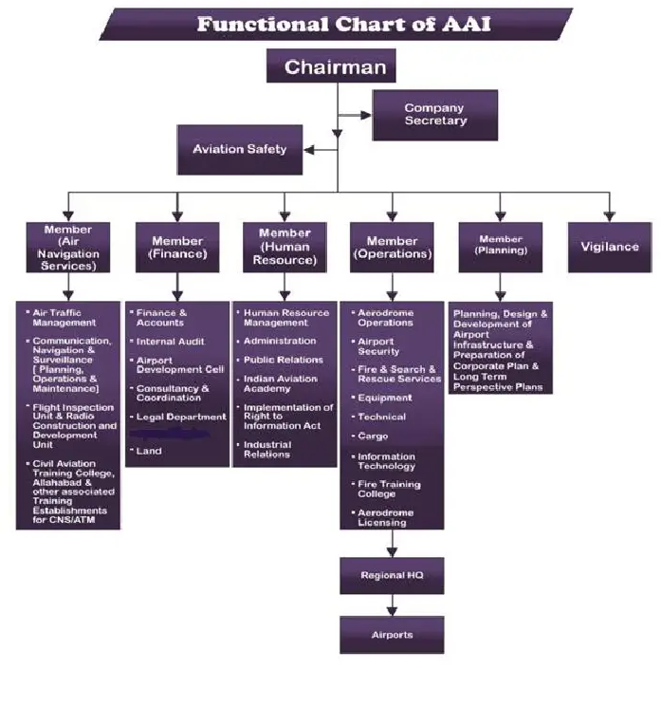

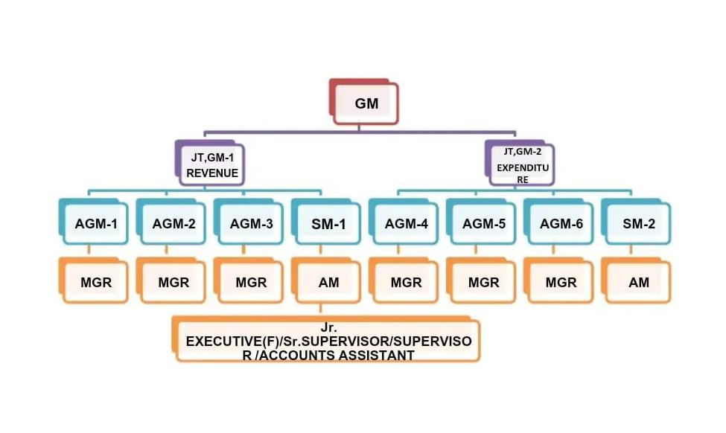**Responsibilities of Finance and Accounts**

* Cash and funds management
* Financial scrutiny of proposals/financial concurrence
* Formulation of proposal for tariff determination (Aeronautical charges)
* Formulation of Annual Revenue and capital Expenditure Budgets
* Maintenance of Cash book, Bank book, General ledger and Subsidiary ledgers
* Compilation of Annual Accounts
* Annual Report for AAI
* Introduction of appropriate accounting policies
* Compilation of Management Information Systems (MIS)
* Debtors Management
* Timely remittance of statutory and other deductions
* Timely filing of statutory returns as per Income Tax, Sales Tax, Service Tax, Service Tax, Foreign trade policy etc.
* Corporate Taxation & statutory levies
* Administration of CPF/Gratuity trusts/Pension
* Safe custody of financial instruments and timely actions for deposits and encashment etc.
* Monitoring of Joint Venture Companies
* Internal Auditing

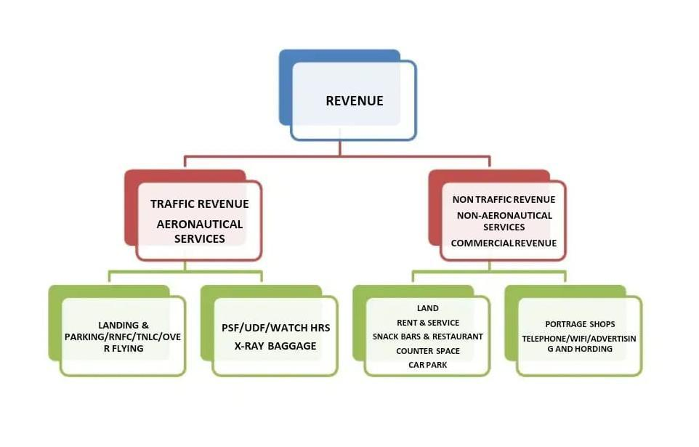

Responsibilities of Revenue Department

1. Creation of Bill to various Airlines & Concessioner in respect of Airport Services & Commercial Contract.
2. Transfer of Bill in respect of Foreign Airlines i.e. Landing & Overflying to IATA
3. Collection of Sundry Debtors
4. Bank Reconciliation.
5. Providing Credit Facilities to Aircraft Operator
6. Preparation of Revenue Budget
7. Reply of Audit Reports & Observation.
8. Provision of Bad Debts etc.
9. Main sources of revenue

Sources of revenue that accrue to AAI can be classified into three categories that are as following

1. Traffic Revenue

2. Non Traffic Revenue

3. Cargo Revenue

4. Airport Leasing Revenue

1. Traffic Revenue comprises of the following

**1. Route Navigation Facilities Charges**-This is charged for navigating the aircraft to its destination from the departed airport. Route navigation is also provided to all overflying aircraft in the Indian airspace. Basically, the charges are charged on weight (All Up Weight) of the aircraft and the distance flown. ATC Radar Controllers provide route navigation.

**Π. Route Navigation Facility Charges (RNFC)**

111. a) RNFC for Landing Flights:

IV. RNFCRs.(RxDxW)

V. R-Rs.4620/-

VI. D=(GCD/100) with GCD cap as 1200 NM

VII. W(AUW/50000) with AUW cap as 2,00,000 Kilograms

VIII. Abbreviations used:

IX .R=Service Unit Rate

X. D-Distance Factor

XI. W-Weight Factor

ΧΙΠ.GCD-Great Circle Distance in NM

ΧΙΠ.AUW All Up Weight of aircraft in Kilograms

XIV.b) **RNFC for Overflying = Rs.(R x D x W) + Rs. 4.400/-**

XV.c**) RNFC for Small Aircrafts registered in India:**

XVI.Route Navigation Facility Charges (RNFC) in respect of aircrafts with maximum All-Up Weight: -

XVII. (a) Up to 10,000 Kg's Shall be levied @ 20% of

the applicable rates of weight-cum-distance formula; and

XVIII.(b) More than 10,000 Kg's to 20,000 Kg's shall be levied @ 40% of the applicable rates of

XIX.weight-cum-distance formula

**II. Terminal Navigation Landing Charges**- This is charged for guiding the aircraft up to the point of touch down. TNLC is applicable at International airports and civil enclaves. Airports which are owned by Defence are categorised as civil enclaves. Generally, ATC Tower controller provides terminal navigation of the aircraft.

XX. a) Major International Airports including

Goa International Airport (Civil Enclave)

XXI. Weight of Aircraft For each landing /

Domestic flight/

XXII.International flights Amount in Rs.

XXIII.Below 10,000 kg's. 1087.90

XXIV. 10,000 kg's and above 6546.10

XXV. b) Civil enclaves (other than Goa International Airport)

XXVI. (i) International Flights

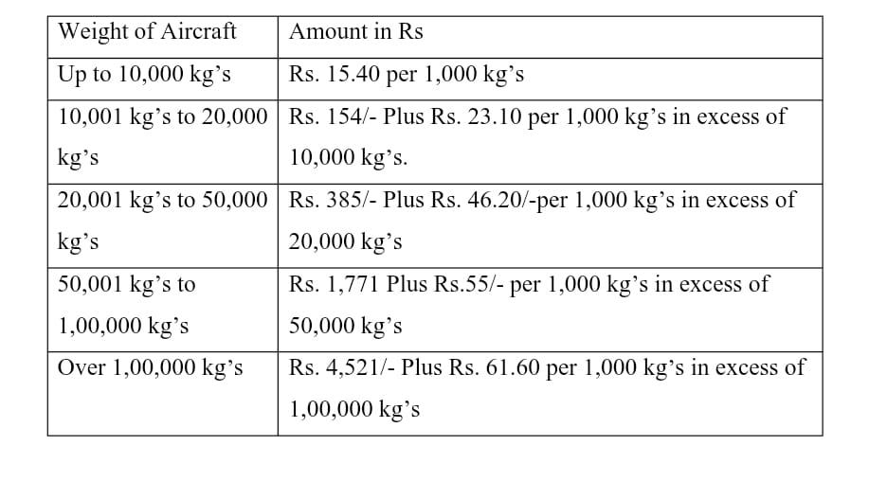

1. Landing charges- This is charged from the point of touchdown to its ultimate parking in the bay. Apron control guides the aircraft from the point of touch down to its ultimate parking in the bay.
2. Parking charges- This is charged for permitting the aircraft to be parked and a half hour in the aprons.
3. Housing charges- This is charged for permitting the aircraft to be parked inside the hanger owned by AAI.
4. Passenger service fees- this is charged for the facilities provided in the terminal as well as for the security arrangements at the airports. The same is collected from all embarking passengers at specified rate from time to time. Bills for PSF are to be raised based on the passenger manifest submitted by the Airlines.
5. User development fee- UDF is charged to cover any deficit in revenues so as to ensure fair return on investment. Bills for UDF are to be raised based on the passenger manifest submitted by the Airlines.

**PROJECT ON CREDIT RISK ANALYSIS**

The outcomes of credit risk analysis, in the context of AAI Visakhapatnam, can be directed towards several key areas:

1. **Pricing Decisions:**
   * Landing Fees and Charges: AAI can adjust landing fees and other charges based on the assessed credit risk of airlines. Higher-risk airlines may be charged higher fees to compensate for the increased risk of default.
   * Concessionaire Leases: Lease rates for retail outlets and other commercial spaces can be differentiated based on the creditworthiness of the concessionaires. Higher-risk concessionaires may be required to pay higher lease rates or provide additional security deposits.
2. **Contractual Terms**:
   * Payment Terms: AAI can negotiate more stringent payment terms with higher-risk airlines and concessionaires, such as requiring upfront payments or shorter payment cycles.
   * Security Deposits: AAI can require higher security deposits from higher-risk entities to mitigate potential losses in case of default.
   * Termination Clauses: Contracts with higher-risk entities can include more stringent termination clauses, allowing AAI to terminate the agreement if the entity fails to meet its obligations.
3. **Resource Allocation**:
   * Credit Limits: AAI can establish credit limits for airlines and concessionaires based on their creditworthiness. This helps to control exposure to credit risk and prevent excessive credit extensions.
   * Risk Monitoring: AAI can allocate resources to closely monitor the financial performance of higher-risk entities to identify potential problems early on.
4. **Risk Mitigation Strategies**:
   * Credit Insurance: AAI can consider purchasing credit insurance to protect itself from potential losses due to airline bankruptcies or other unforeseen events.
   * Diversification: AAI can actively seek to diversify its revenue streams by attracting a mix of airlines, concessionaires, and other stakeholders with varying risk profiles.
5. **Decision-Making**:
   * Investment Decisions: Credit risk analysis can inform AAI's investment decisions, such as whether to invest in new infrastructure or expand existing facilities.
   * Strategic Partnerships: AAI can use credit risk analysis to evaluate potential partners for joint ventures or other collaborative initiatives**.**

By effectively directing the outcomes of credit risk analysis, AAI Visakhapatnam can make more informed decisions, enhance its financial stability, and protect its revenue streams.

Saturday, 18 January 2025